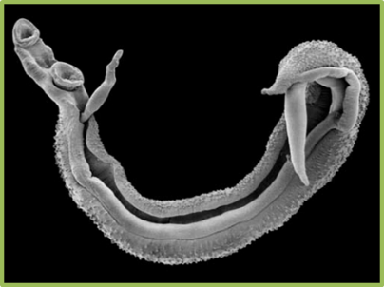
Teaching about the Prevention, Control, and
Treatment of Intestinal Schistosomiasis

Teacher’s Guide for
Activities and Safe Play

Teaching Prevention, Control, and Treatment of Urogenital Schistosomiasis
Teacher Lesson Plans

Activities Packet
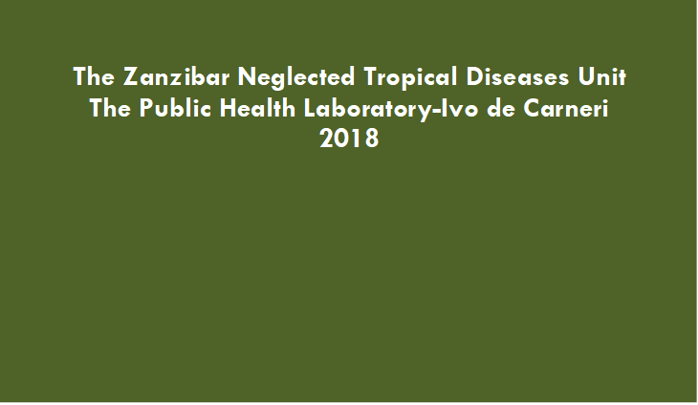

Acknowledgement

We would like to acknowledge the Behaviour Change Teams on Pemba and Unguja Islands, as well as all the teachers and students who were part of the ZEST study and provided feedback on the intervention components. These materials could not have been completed without the assistance of Faiza Mohammed A’Kadir, Said Ali Mohammed, Ulfat Mohammed, Fatma Kabole, and the teachers who provided valuable input during pretesting sessions. For more information, contact the Global Schistosomiasis Alliance: https://www.eliminateschisto.org/

Contents

Introduction 3

Lesson Plan Activities 4
Lesson 1 Activity: Draw something fun to do 5
Lesson 2 Activity: Draw the blood fluke 6
Lesson 3 Activity: Identify the schistosomiasis snail 7
Lesson 4 Activity: The blood fluke life cycle 8
Lesson 5 Activity: Count the schistosomiasis snails 9
Lesson 7 Activity: Play the treatment game 11

Safe Games 12
Safe Game 1: Skipping rope 13
Safe Game 2: Tug-of-war 14
Safe Game 3: Sack race 15
Safe Game 4: Running race 16
Safe Game 5: Doughnut game 17
Safe Game 6: Toss game 18
Safe Game 7: Balloon race 20
Safe Game 8: Water race 21

Performances 22
Performance 1: Dramas and stories 23
Performance 2: Poems and songs 25

Introduction

Students learn best when they are active participants in learning. They like to draw pictures, play games, and perform for others. Teachers can help children learn about schistosomiasis through activities and games that are fun. This Teacher’s Guide for Activities and Safe Play includes instructions for three types of activities to support active learning about prevention, control, and treatment of schistosomiasis:
- Lesson Activities: These activities reinforce concepts in the Teacher Lesson Plans document. Most but not all of the lessons have activities associated with them.
- Safe Games: Safe Games can be played as part of lessons, school-wide events, or on their own. Besides keeping children out of contaminated water, they offer an opportunity to reinforce lessons about schistosomiasis.
- Performances: These include plays, stories, poems, and songs. Children can learn by creating and/or performing these.

Each instruction sheet explains the objective of the activity or game, needed supplies, and how to conduct the activity or game. Please take time to review the instruction sheets and obtain any necessary supplies before working with your students. Have fun!

Teacher Lesson Plan Activities

The materials in the Teacher Lesson Plans are designed to teach students about prevention, control, and treatment of intestinal schistosomiasis. It encourages use of active learning approaches. Active learning means that the children participate in the classroom by answering questions, doing activities, and being part of discussions. The activities in this section of the Teachers Guide for Activities and Safe Play are linked to the lesson plans in the Teacher Lesson Plans document.

Lesson 1 Activity: Draw something fun to do

Purpose
Reinforce the idea that children get schistosomiasis from contact with freshwater sources and that there are many fun activities that don’t involve water contact

Supplies
- Drawing paper
- Crayons, markers, or pencils

Instructions
- Remind the students that people get schistosomiasis from being in freshwater places, like streams, ponds, lakes, rivers, and rice fields.
- Ask them to draw a child or children having fun without going in the water.
- Have 2 or 3 students show their pictures to the class and talk about the activity shown in their pictures.
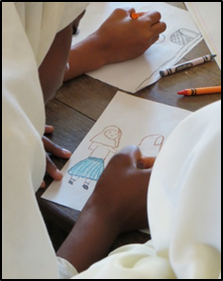

Lesson 2 Activity: Draw the blood fluke

Purpose
Teach students what the blood fluke looks like

Supplies
- Drawing paper
- Crayons, markers, or pencils

Instructions
- Give each student a piece of paper and a crayon, marker, or pencil.
- Ask each student to draw a picture of a blood fluke.
- Have one or two children show their drawings and talk about the blood fluke, including why it is different from a common worm.

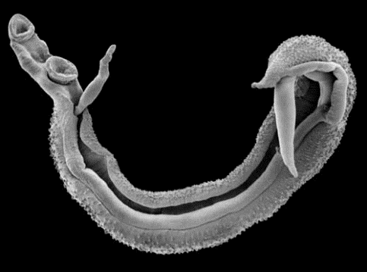
Blood Fluke

Lesson 3 Activity: Identify the schistosomiasis snail

Purpose
Teach students to identify the schistosomiasis snail

Supplies
- A sample snail board showing three different types of snail shells and descriptions, as in the picture
- 8-inch x 4-inch boards – 1 per student
- Glue
- Labels for each of the 3 snails – 3 per student
- 3 types of snail shells, including the schistosomiasis snail (for intestinal schistosomiasis, this is the Biomphalaria snail). Have enough to give 2-3 of each to each student

Instructions
- Show the prepared snail board to the students.
- Discuss the differences between the schistosomiasis snail and other snails on the snail board. The schistosomiasis snails are the small snails on the left.
- Give each student a board and 2-3 of each type of snail, as well as 3 labels.
- Have the students glue the snails on the board.
- Have the students write descriptions on the labels and glue them on too.
- Have one or two students show their snail boards and talk about the different types of snails.

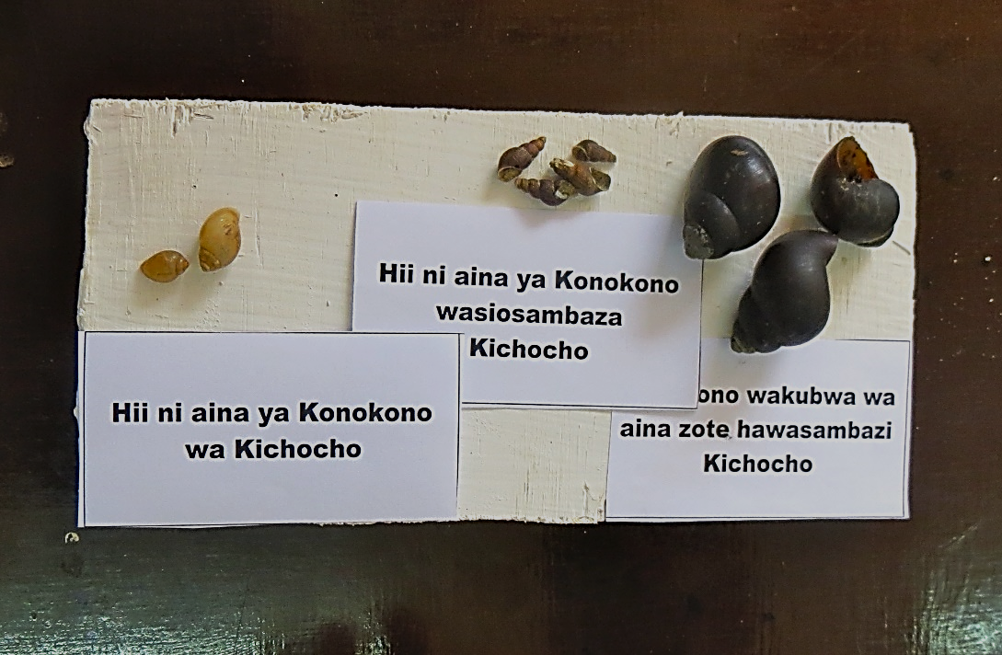
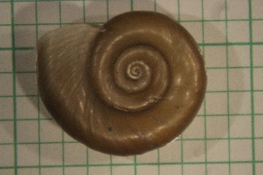
Create a board with snails from your area, including the Biomphalaria snail.

Lesson 4 Activity: The blood fluke life cycle

Purpose
Teach students to understand the life cycle of the schistosomiasis blood fluke

Supplies
- Cardboard template of a boy or girl
- Manila or colored paper
- Crayons, colored pencils or markers
- Scissors
- Glue

Instructions
- After discussing the life cycle of the blood fluke, ask each student to make a poster depicting the life cycle.
- Give each child a cardboard template.
- Ask the students to trace around the template to draw their own girl or boy. Ask them to fill in the outline with a face and clothes. They can then add the various images in the life cycle, as shown in the pictures below. Be sure the feet of the person are in the water.
- Have one or two students show their pictures and explain the life cycle.

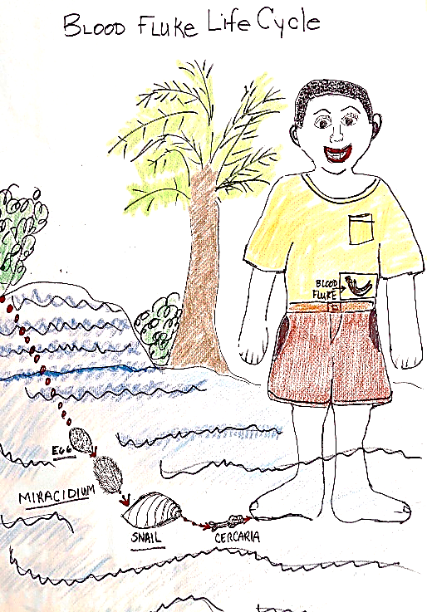
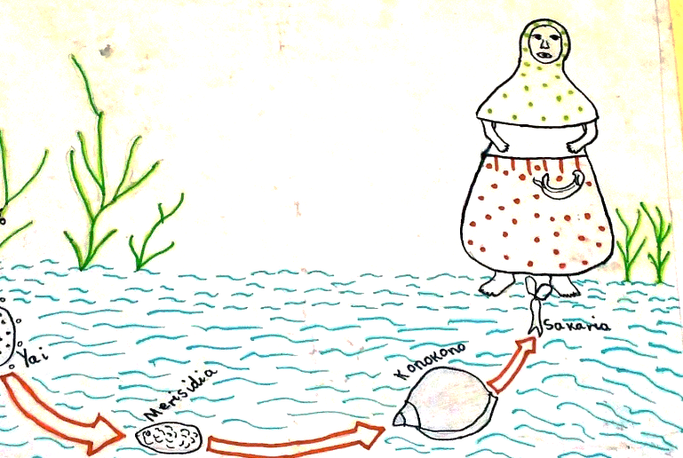

Lesson 5 Activity: Count the schistosomiasis snails

Purpose
Teach students where the schistosomiasis snail might live

Supplies
Activity 5 Worksheet: Count the schistosomiasis snails

Instructions
- Remind students that:
  - Schistosomiasis lives in very small snails found in rivers and streams.
  - They should not go in water where these snails might live.
  - Snails that live on land do not carry schistosomiasis.
- Ask students to circle all the schistosomiasis snails that they find in the picture on the worksheet.
- Ask them to write the total number on the line provided.
- Check the students’ work. Did they only count the tiny snails that are in the water?
[Answer: 8]
- Ask how they got their answers. If they make mistakes, review the difference between where the schistosomiasis snails live and where other snails live.

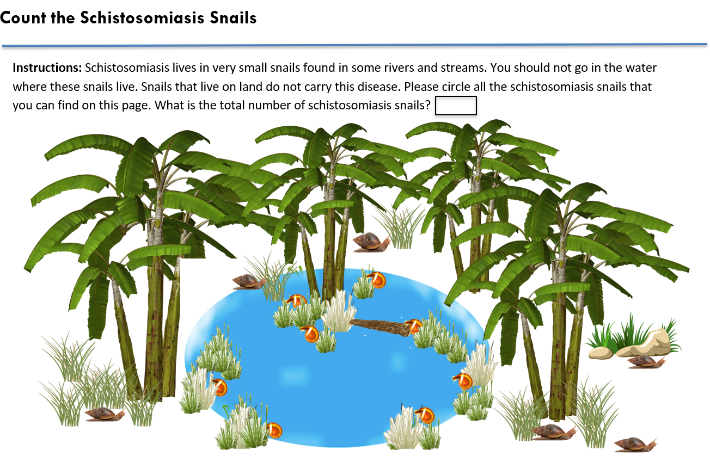

Lesson 7 Activity: Play the treatment game

Purpose
Teach students about praziquantel, the treatment for schistosomiasis

Supplies
- At least 3 praziquantel tablets
- 3 cups

Instructions
- Explain that praziquantel is a white tablet that kills the blood fluke.
- Show the sample praziquantel tablets.
- Explain that:
  - The amount of drug you take is decided by your weight or height.
  - You must swallow praziquantel tablets all together to kill the blood fluke.
  - During mass drug administration campaigns, all the children are treated with praziquantel for schistosomiasis.
  - Sometimes everyone in a community is treated with praziquantel for schistosomiasis.
  - Remind the students that people without symptoms can be sick with schistosomiasis. The blood fluke and eggs can be doing damage in the body even without symptoms.
- Play the game using three tablets.
  - Show the students the tablets.
  - Hide the tablets under one of the three cups and move the cups quickly to confuse the students about which cup hides the tablets.
  - Have students guess, which cup the tablets, are under.
  - Show the students which cup hides the tablets.
  - Tell the students, “If you guessed wrong, you have schistosomiasis. The health worker gives you three tablets. How many should you take? [Answer: 3]
  - Break one of the tablets in half and repeat using 2-1/2 tablets.
  - When the students guess, say, “If you guessed wrong, you have schistosomiasis. The health worker gives you 2-1/2 tablets. How many should you take?” [Answer: 2-1/2]

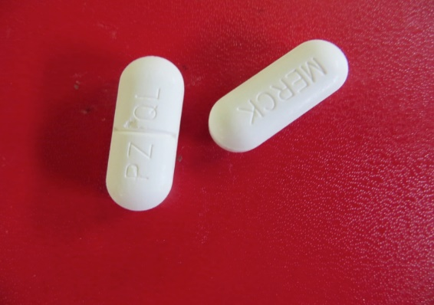

Safe Games

In addition to classroom-based activities, students can learn about schistosomiasis through playing games. Included here are instructions and discussion guides for eight safe games that children can play that keep them out of contaminated water. These games also teach about preventing schistosomiasis. Each instruction sheet explains the purpose of the game, identifies the appropriate age group and needed supplies, and how to play. Most important, each sheet provides questions to be asked of all students participating in the game. The questions reinforce schistosomiasis prevention and control messages. Behavior change requires consistent messages, over time, presented many times. The games suggested here can be conducted during regular recess on a school day or as part of a school-wide event. They can be used at any community or religious gathering where children might be playing.

Safe Game 1: Skipping rope

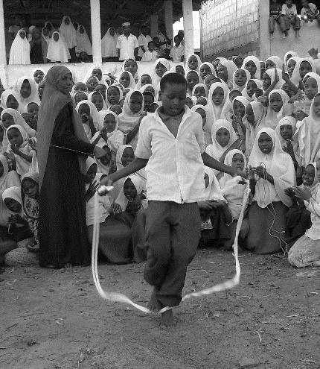

Purpose: Provide a safe game and teach students about schistosomiasis

Age: Standard Grades 3-7

Supplies:
5 jump ropes, one for each student

Note: The rope should not go past the students’ shoulders when they stand on the middle of the rope and bring the handles up by their sides.

Instructions:
Before each game, tell the students that they need to win if they don’t want to get schistosomiasis -- the losers are infected!
- Ask five students to start jumping rope at the same time. Ask them to sing a schistosomiasis rhyme while jumping. For example, they can sing, “How many tablets did I take? Was it one…two…”
- When a student missteps, they stop to let that person leave, and then they restart. The last student left skipping rope is the winner!

Questions:
- Say to the losers, “I am so sorry. You have schistosomiasis.” Ask the losers questions like:
- How did you get schistosomiasis?
- How do you know you have schistosomiasis?
- What are your symptoms?
- How will you be treated?
- How will you prevent getting schistosomiasis next time?
- Say to the winner, “It’s great. You do not have schistosomaisis.” Ask the winner questions like:
- How did you prevent getting schistosomiasis?
- What did you avoid doing to prevent getting schistosomiasis?
- What safe games did you play?
- What would you tell your friends who got schistosomiasis so they don’t get it again?

Safe Game 2: Tug-of-war

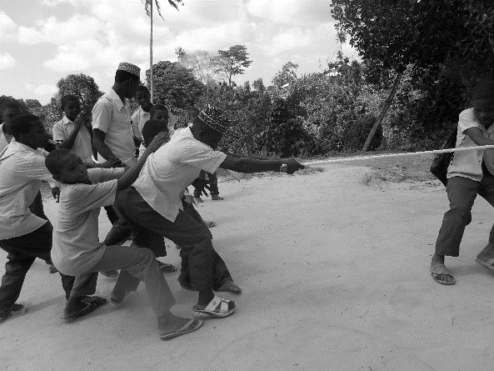
Purpose: Provide a safe game and teach students about schistosomiasis

Age: Standard Grades 3-7

Supplies:
- A thick rope 5 meters long. Put a red mark in the middle of the rope. Put a black mark 2 meters on either side of the red mark.
- You may want to have a whistle to start the game.

Instructions:
- Play the game on a flat grassy patch of land or large floor. Place the middle red line of the rope over a line drawn on the ground.
- Assign two teams of 5 students to each side of the rope. Try to make sure the weights of both teams are about the same.
- Ask each team to line up in single file on their side of the rope.
- The first student on each team places their hands on the black mark. The rest of the team members pick up the rope behind the first team student. The objective of the game is for each team to pull the rope along with the members of opposition team to their side.
- Blow a whistle or use another way to start the game. When the whistle is blown, each team starts pulling the rope into their territory.
- As soon as the black mark on the rope crosses the centerline on the ground the game is over. The team to pull the rope over the line wins the game. The winning team does not get schistosomiasis. The losing team members have fallen into the river and now have schistosomiasis.

Questions:
- Say to the losers, “I am so sorry. You have schistosomiasis.” Ask the losers questions like:
- How did you get schistosomiasis?
- How do you know you have schistosomiasis?
- What are your symptoms?
- How will you be treated?
- How will you prevent getting schistosomiasis next time?
- Say to the winners, “It’s great. You do not have schistosomaisis.” Ask the winners questions like:
- How did you prevent getting schistosomiasis?
- What did you avoid doing to prevent getting schistosomiasis?
- What safe games did you play?
- What would you tell your friends who got schistosomiasis so they don’t get it again?

Safe Game 3: Sack race

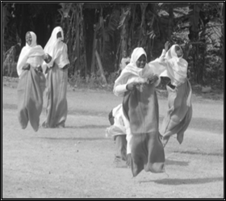
Purpose: Provide a safe game and teach students about schistosomiasis

Age: Standard Grades 1-7

Supplies:
- 8 burlap sacks – 1 sack per student
- 2 flags or ropes to mark start and finish lines
- 1 whistle or flag to signal the start of the race

Instructions:
- Play the game on a flat grassy patch of land or large floor. Mark a start and a finish line, about 20-30 feet apart, depending on the age of the students.
- Identify 8 students. Line up the students on the starting line. Line up the sacks 5 to 10 feet from them.
- When you blow the whistle, have the students rush to the burlap sacks.
- Tell each student to pull a sack over both feet and hold it to his or her waist to mid-chest height.
- Tell students to hop toward the finish line as fast as they can.
Notes:
- Both feet must remain in the sack at all times.
- At least one hand must be on the sack at all times.
- The sack must remain as close to the waist as possible and cannot fall below the knees.
- The first student to reach the finish line wins! The others lose.
- The students are asked the special questions.

Questions:
- Say to the losers, “I am so sorry. You have schistosomiasis.” Ask the losers questions like:
- How did you get schistosomiasis?
- How do you know you have schistosomiasis?
- What are your symptoms?
- How will you be treated?
- How will you prevent getting schistosomiasis next time?
- Say to the winner. “It’s great. You do not have schistosomaisis.” Ask the winner questions like:
- How did you prevent getting schistosomiasis?
- What did you avoid doing to prevent getting schistosomiasis?
- What safe games did you play?
- What would you tell your friends who got schistosomiasis so they don’t get it again?

Safe Game 4: Running race

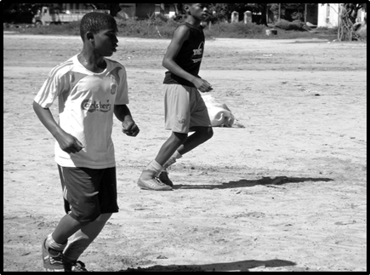
Purpose: Provide a safe game and teach students about schistosomiasis

Age: Standard Grades 1-7

Supplies:
- 2 flags to mark a start and finish line
- 1 whistle or flag to signal the start of the race
- A field large enough for two teams to run a short distance

Instructions:
- Identify 12 students. (You can choose a different number if you want.)
- Divide students into two teams of 6.
- Ask half of the team to line up on one side of the field and the other half to line up on the other side. (A team of 6 has 3 participants on each side facing each other.)
- Decide which side of the field will be the starting side. This will also be the starting side.
- The whistle blows and starting side student from each team runs to the other side and tags the next student.
- The next student runs back to the other side of the field.
- Repeat the tagging until the entire team has switched sides of the field.
- The first team to get all members to the opposite side of the field WINS! The other team loses.

Questions:
- Say to the losers, “I am so sorry. You have schistosomiasis.” Ask the losers questions like:
- How did you get schistosomiasis?
- How do you know you have schistosomiasis?
- What are your symptoms?
- How will you be treated?
- How will you prevent getting schistosomiasis next time?
- Say to the winners, “It’s great. You do not have schistosomaisis.” Ask the winners questions like:
- How did you prevent getting schistosomiasis?
- What did you avoid doing to prevent getting schistosomiasis?
- What safe games did you play?
- What would you tell your friends who got schistosomiasis so they don’t get it again?

Safe Game 5: Doughnut game

Purpose: Provide a safe game and teach students about schistosomiasis

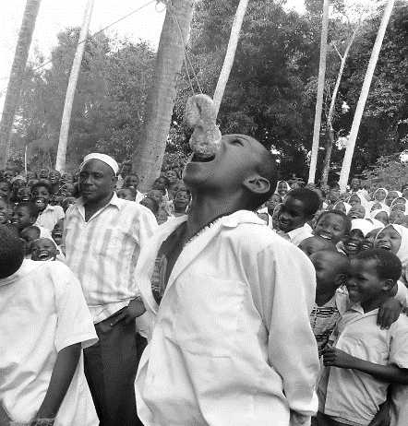
Age: Standard Grades 3-7

Supplies:
- Enough doughnuts for all players. Typically, this might be 6 players
- Ball of string
- Scissors

Instructions:
- Tie a length of rope between two trees.
- Select the students who will play.
- Ask the players to stand under the rope.
- Tie pieces of string to the doughnuts (one per player).
- Tie the doughnuts to the rope slightly above mouth level. You may need to have the doughnuts at different heights.
- Have players start to eat the donut on the count of three. Students are to eat the doughnut without using their hands. They must eat and swallow the entire doughnut to be considered finished.
- First student to finish their entire doughnut wins! The other students are the losers.

Questions:
- Say to the losers, “I am so sorry. You have schistosomiasis.” Ask the losers questions like:
- How did you get schistosomiasis?
- How do you know you have schistosomiasis?
- What are your symptoms?
- How will you be treated?
- How will you prevent getting schistosomiasis next time?
- Say to the winner. “It’s great. You do not have schistosomaisis.” Ask the winner questions like:
- How did you prevent getting schistosomiasis?
- What did you avoid doing to prevent getting schistosomiasis?
- What safe games did you play?
- What would you tell your friends who got schistosomiasis so they don’t get it again?

Safe Game 6: Toss game

Purpose: Provide a safe game and teach students about schistosomiasis

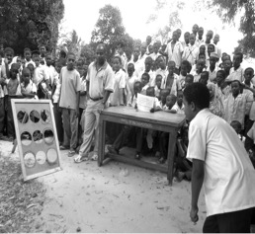
Age: Standard Grades 1-7

Supplies:
- 1 toss game board (see next page for instructions on how to make this)
- 3 stones or bottle caps

Instructions:
- Identify 6 students.
- When it’s their turn, each player receives 3 stones or bottle caps and stands 1-2 meters away from the board, depending on age.
- Each student is given 3 tries to get a stone or bottle cap into the holes in the middle (the football holes).
- If the student gets a stone or bottle cap into a football hole, they did not fall into water. They are a winner!
- If the student gets a stone or bottle cap in the snail hole or doesn’t get the stone or bottle cap into any holes, they have fallen in the water. They have lost!

Questions:
- Say to the losers, “I am so sorry. You have schistosomiasis.” Ask the losers questions like:
- How did you get schistosomiasis?
- How do you know you have schistosomiasis?
- What are your symptoms?
- How will you be treated?
- How will you prevent getting schistosomiasis next time?
- Say to the winners, “It’s great. You do not have schistosomaisis.” Ask the winner questions like:
- How did you prevent getting schistosomiasis?
- What did you avoid doing to prevent getting schistosomiasis?
- What safe games did you play?
- What would you tell your friends who got schistosomiasis so they don’t get it again?

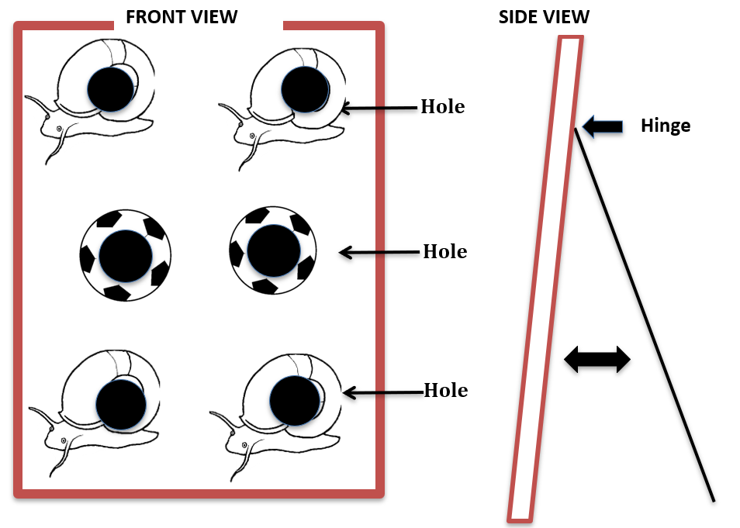
Building a Toss Game Board (see diagram)

Supplies:
- 1 board, 1 meter by ¾ meter with 6-8 holes, spread evenly made in 3-4 rows
- 1 board, ¾ meter by ½ meter to be a leg in the back of the board so it will stand
- 1 hinge with screws to attach the leg to the main board
- Paint
- 3 small stones or bottle caps to toss into the holes for the game. These can be painted.

Instructions:
- Attach the back leg to the center of the front board so it will stand
- Paint the top and bottom holes to be snails
- Paint the center holes to be footballs
- Allow to dry

Safe Game 7: Balloon race

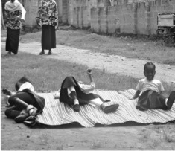
Purpose: Provide a safe game and teach students about schistosomiasis

Age: Standard Grades 1-3

Supplies:
- 27 blown-up balloons
- Long string
- Mat

Instructions:
- Identify 9 students to play.
- Split students into 3 teams.
- Place a large mat on the ground at one end of the field.
- Ask the teams to line up on the other end of the field.
- Tie 3 balloons to the waist of each student. The balloons should hang down in back of them by a few inches.
- One student per team runs to the mat, lies down, and busts all their balloons.
- When all their balloons are busted, the student runs back to their team.
- The next student repeats this and returns for the final student.
- The first team to bust all their balloons wins.

Questions:
- Say to the losers, “I am so sorry. You have schistosomiasis.” Ask the losers questions like:
- How did you get schistosomiasis?
- How do you know you have schistosomiasis?
- What are your symptoms?
- How will you be treated?
- How will you prevent getting schistosomiasis next time?
- Say to the winners, “It’s great. You do not have schistosomaisis.” Ask the winners questions like:
- How did you prevent getting schistosomiasis?
- What did you avoid doing to prevent getting schistosomiasis?
- What safe games did you play?
- What would you tell your friends who got schistosomiasis so they don’t get it again?

Safe Game 8: Water race

Purpose: Provide a safe game and teach students about schistosomiasis

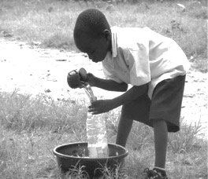
Age: Standard Grades 1-3

Supplies:
- 2 basins filled with water
- 2 empty basins
- 2 cups
- 2 one-liter bottles

Instructions:
- Identify 8 students to play.
- Split students into 2 teams.
- Place a cup in the filled basins with water at one end of the field, and place the empty basins at the opposite end.
- Ask each team to line up at the end of the field with the empty basin.
- The first student on each team takes a 1-liter plastic bottle and runs down to the basin filled with water and uses the cup to fill their bottle. Have a teacher or someone else observe to make sure the bottle is full.
- The student runs to the empty basin and empties their bottle into the basin. They hand the bottle to the next student. The next student runs to the water-filled basin and repeats the sequence. This is repeated until all students have filled and emptied the bottle once.
- The first team to have every teammate fill a water bottle and empty it into the basin that started out empty is the winning team.

Questions:
- Say to the losers, “I am so sorry. You have schistosomiasis.” Ask the losers questions like:
- How did you get schistosomiasis?
- How do you know you have schistosomiasis?
- What are your symptoms?
- How will you be treated?
- How will you prevent getting schistosomiasis next time?
- Say to the winners, “It’s great. You do not have schistosomaisis.” Ask the winners questions like:
- How did you prevent getting schistosomiasis?
- What did you avoid doing to prevent getting schistosomiasis?
- What safe games did you play?
- What would you tell your friends who got schistosomiasis so they don’t get it again?

Performances

Writing and performing plays, poems, and stories is a great way to reinforce what children have learned about schistosomaisis. These can be very short and be a small part of a classroom lesson. Or they can be longer and involve many students working together. Sometimes, children perform these as part of school-wide events.

Performance 1: Dramas and stories

Purpose: Provide an opportunity for students to learn about schistosomiasis by writing plays or stories and observing others performing them

Age: Standard Grades 2-10

Supplies:
- Paper, pens, pencils to write plays or stories about schistosomiasis, or student- or teacher-prepared plays
- Props needed for the play or skit
- Microphone and speaker if the school attendance is large

Topics and Notes:
- Some possible topics for dramas are:
  - How do children get schistosomiasis?
  - How do children know that they have schistosomiasis?
  - How is schistosomiasis treated?
  - How can children prevent getting schistosomiasis?
  - How can children talk to their parents about schistosomiasis?
  - What can children do if there is no tap water – only stream or pond water?
- Teachers can follow-up on the drama by asking questions of the audience, like:
  - What would you do in this situation?
  - Is there anything else that the characters could have done?

Example of a simple script: John talks with his friends about schistosomiasis

Setting: John is walking by a lake where many of his friends are swimming. They call for him to come and join them. John has a conversation with 3 friends.

David: Hey John, where are you going? Come on in to swim. The water is great. It is so hot today!

John: No thanks. I am never going in that water again. I used to go swimming there. Then I got very sick. My belly hurt down here. It was so painful.

Cliff: So what did you eat that made you so sick?

Mohammed: I felt like that last year. It was really painful. It lasted a long time. I didn’t get that from eating something bad!

Cliff: So what made you so sick?

John: We have been learning about this creature called a blood fluke in school. It lives in your body and makes you sick with schistosomiasis. The blood fluke comes from very tiny snails that are in that water where you are swimming. I got this infection from swimming in the water where you are now! That’s what made me so sick! These blood flukes are so ugly and so dangerous!

David: What do these blood flukes look like? I haven’t seen anything in the water.

John: You can’t see these with your eyes when they are in the water. But I saw a picture in school. They are so scary! When they are inside you they can lay hundreds of eggs every day. And when you poo near the lake the eggs get out and are washed into the lake. Then they hatch and go to live in the tiny snail. They wait for other children to get in the water so they can infect them. They doctor told me I can get infected every time I get in the water. I don’t want to ever get this again! It is too painful. If you keep getting infected you can even end up with liver and intestine damage. There is a man not far away that has that. He is very sick. No way I am going swimming again in that water!

Cliff: But swimming is so much fun! What are you going to do for fun?

John: There are so many other games I can play for fun. We had a safe play event at school and I learned about other fun games. My dad bought me a rope and now I can skip rope and play tug-of-war with my brothers. We can play football and race each other. We still have lots of fun! If you want to you can come play with me now. The longer you stay in the water the greater your chance of getting sick!

David and Mohammed: Wow, we are coming with you. I don’t want to have something living inside of me making me sick! That sounds horrible! Come on Cliff let’s go.

Examples of questions the teacher could ask after this play:
- What would you do in this situation?
- What do you think Cliff will do?
- Is there anything else that John could or should have told his friends?

Performance 2: Poems and songs

Purpose: Provide an opportunity for students to learn about schistosomiasis by creating poems or songs and listening to poems or songs by others

Age: Standard Grades 1-7

Supplies:
- Paper, pen, pencil, or student- or teacher-prepared poems or songs
- Sample poems

Topics and Notes:
- Some possible topics for poems are:
  - How do children get schistosomiasis?
  - How do children know that they have schistosomiasis?
  - How is schistosomiasis treated?
  - How can children prevent getting schistosomiasis?
  - How can children talk to their parents about schistosomiasis?
  - What can children do if there is no tap water – only stream or pond water?

Instructions
- Read a sample poem to the students. Sample poem:

When we sometimes play in a pond or stream
We get infected with something that can’t be seen.
In our body lives a dangerous creature;
It has male and female, an unusual feature.
It is a blood fluke, not a worm, that causes us pain,
Not a bug or bacteria that we can blame.
It travels in our blood and lives in our liver;
It can make us so sick just from playing in the river.
If you don’t want to get desperately ill
Use safe water and take this pill.

- Ask: What did you learn from this poem?
- Give each student paper and pencil.
- Ask students to write a poem about schistosomiasis, with 6-10 lines that rhyme.
- Walk around the room and provide praise for their efforts; answer questions.
- Ask for five students to read their poems to the class.

