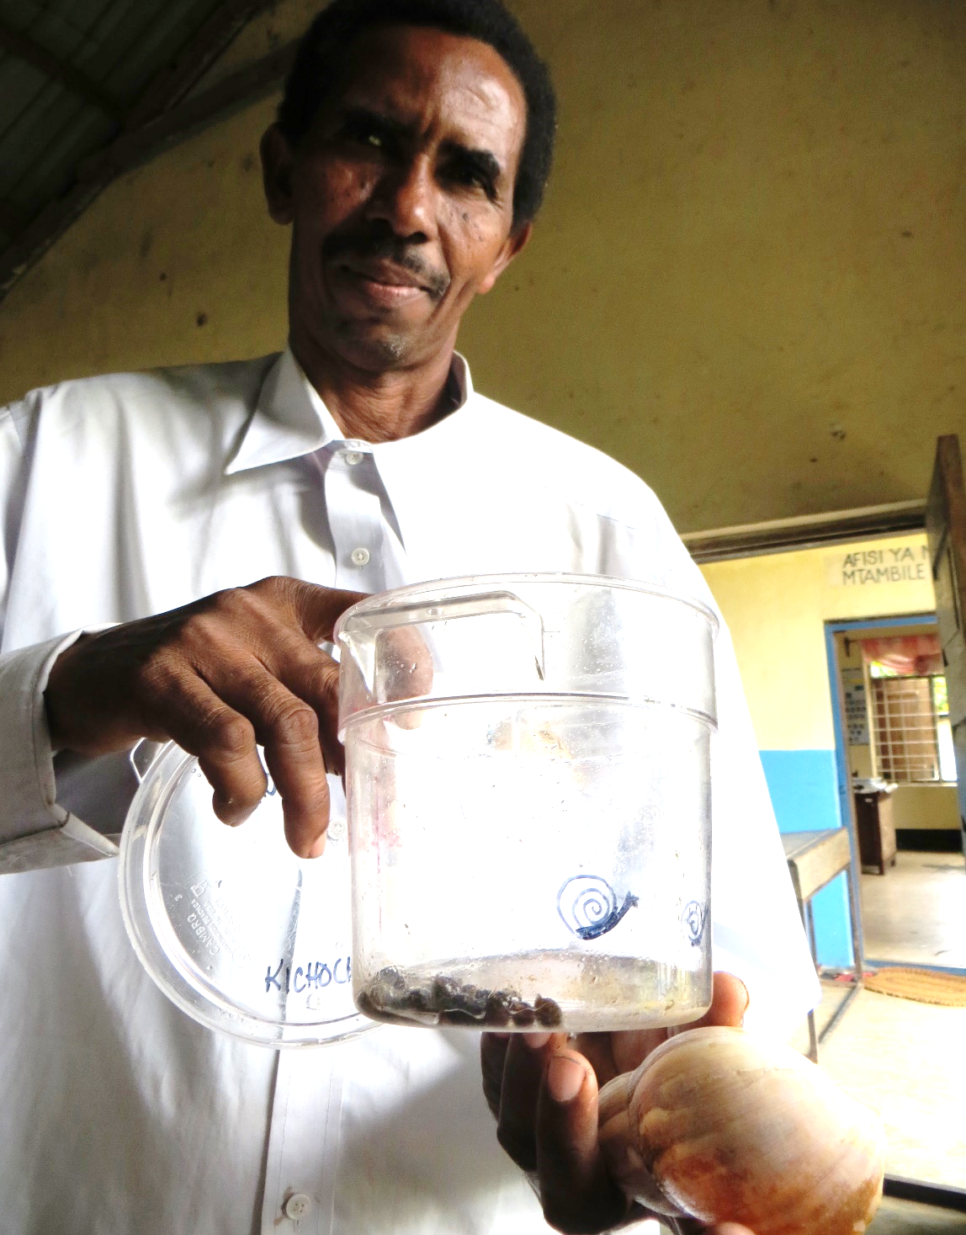
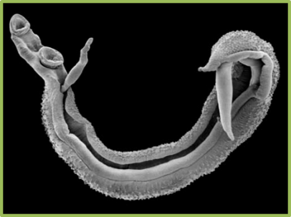

Teaching about the Prevention, Control, and
Treatment of Urogenital Schistosomiasis

Teacher Lesson Plans

Acknowledgements

We would like to acknowledge the Behaviour Change Teams on both Pemba and Unguja Islands of Zanzibar, as well as all the teachers and students who were part of the study and provided feedback on the intervention components. The set of materials could not have been completed without the assistance of Faiza Mohammed A’Kadir, Said Ali Mohammed, Ulfat Mohammed, Fatma Kabole, and the teachers who provided valuable input during pretesting sessions.

For more information contact the Global Schistosomiasis Alliance on https://www.eliminateschisto.org/

Contents

Page

Active learning reminder 3
Lesson 1: What is urogenital schistosomiasis? 4
Lesson 2: What is a blood fluke? 6
Lesson 3: What is the role of the schistosomiasis snail? 9
Lesson 4: What is the life cycle of the blood fluke? 11
Lesson 5: What behaviors put children at risk for schistosomiasis? 14
Lesson 6: What are the symptoms of urogenital schistosomiasis in children? 16
Lesson 7: How do you test for and treat schistosomiasis? 18
Lesson 8: How can safe games and activities help prevent schistosomiasis? 20

Active learning reminder

Remember, teachers can have a great impact on students by using active learning approaches. Active learning approaches will improve how much students learn about almost any topic. Before starting your lesson plans review the active learning notes below.

Important notes

- An effective learning environment is one where students feel welcomed, respected, and part of the learning process
- Set up the space ahead of time
- Have teaching materials and supplies ready to use
- Always be on time – be a role model
- Turn off your phone
- Avoid lecturing and just reading slides
- Tell stories and use real-life examples
- Smile and move around the room
- Encourage guessing, even if children don’t know the right answers
- Be positive and give praise, for example, “This discussion has been so good. I can tell you are really thinking about this issue. I can tell that you really want to learn!”
- Use games and activities
- Provide time to practice and ask questions
- Check for understanding

Lesson 1: What is urogenital schistosomiasis?

Objective:
To understand and discuss the cause of schistosomiasis, how schistosomiasis is spread, and symptoms of urogenital schistosomiasis
Activity:
Draw something fun to do
Materials:
Flipchart A: What is urogenital schistosomiasis?
Time:
Presentation and discussion: 20 minutes

Ask: What do you know about schistosomiasis?
Answer: Schistosomiasis, also known as bilharzia, is an infection caused by a parasite. A parasite is an organism that lives in or on another creature. The parasite that causes schistosomiasis is a blood fluke. Schistosomiasis mainly affects boys and girls 5-14 years old in Africa. Adults can also have schistosomiasis.

Ask: Do you know anybody who has had schistosomiasis?

Ask: What is urogenital schistosomiasis?
Urogenital schistosomiasis is a kind of schistosomiasis. All kinds of schistosomiasis can make people tired and make it harder for children to learn and grow. Urogenital schistosomiasis can make you pee blood. It can damage to the bladder and can affect the ability of girls to have babies. The medical way of saying this is that it affects the urogenital system. That’s why we call the disease “urogenital schistosomiasis.”

Ask: How do you get schistosomiasis?
Answer: Schistosomiasis is caused by a parasite called the blood fluke. The blood fluke lives part of its life in a special kind of small snail that lives in streams, ponds, lakes, rivers, and rice fields.

These schistosomiasis snails carry the schistosomiasis parasites, just like mosquitoes carry malaria. When somebody who has schistosomiasis pees in the water, eggs come out in their urine. The eggs hatch in the water and infect the schistosomiasis snails.

When a snail is infected, it releases tiny immature blood flukes, called cercariae, into the water. They are so tiny you cannot see them. When you get into water with cercariae, they can enter your body through your skin. Once in your body, they can become mature blood flukes. Every time a person steps in fresh water where infected snails live, they can get schistosomiasis.

Ask: What are symptoms of schistosomiasis?
Answer: Schistosomiasis causes children to have less energy and have problems learning. Schistosomiasis can keep children from growing as much as they should. When schistosomiasis lasts a long time, it can cause scarring in the bladder and kidneys. This can lead to bladder cancer. Schistosomiasis that is not treated for a long time can also interfere with women having babies.

Ask: Can you prevent schistosomiasis?
Answer: Yes, you can prevent schistosomiasis by staying out of water where infected snails live. You can help prevent other people from getting schistosomiasis by not peeing in streams, ponds, lakes, rivers, and rice fields that have schistosomiasis snails.

Ask: Can you treat schistosomiasis?
Answer: Schistosomiasis can be treated with a strong medicine called praziquantel. If treated early, people recover totally. Even if you were treated, if you go back into water with infected schistosomiasis snails you can get schistosomiasis again.

Lesson 1 Activity: Draw something fun to do (optional)

Show Flipchart A: What is urogenital schistosomiasis?
- You can use the questions on the back of the flipchart to review Lesson 1.

Check for understanding
Ask: What is schistosomiasis?
Ask: Can you prevent schistosomiasis?
Ask: Can you treat schistosomiasis?

Important note
Schistosomiasis can be prevented, but if you get it, you can be treated and it will go away.

Lesson 2: What is a blood fluke?

Objective:
To describe and discuss the role of the blood fluke in schistosomiasis transmission
Activity:
Draw the blood fluke
Materials:
Flipchart B: The blood fluke
Teacher’s Guide for Activities and Safe Play: Lesson 2 Activity
Drawing paper
Crayons, markers, or pencils
Time:
Presentation and discussion: 15 minutes
Activity: 30 minutes

Ask: How many of you have ever had worms?
[Count the number of people and write it on the board.]

Ask: What did the worms you had look like?
[On the board or paper, draw a picture of a common worm. This will usually be a thin wiggly picture, like a thin noodle.]

Ask: Is this what you are talking about? (Point to the drawing of the common worm. On the board or paper.)

Answer: Explain that this is not a blood fluke. A blood fluke is different from the common type of worm that everyone has had in the past! It is not to be confused with a common worm!

Ask: So, what is the schistosomiasis blood fluke?
Answer: The blood fluke is the parasite that causes schistosomiasis. A parasite is an organism that lives in or on another creature. When a person has schistosomiasis, the blood fluke lives inside their body. (Now show the picture of the blood fluke from the flipchart section B to each student).

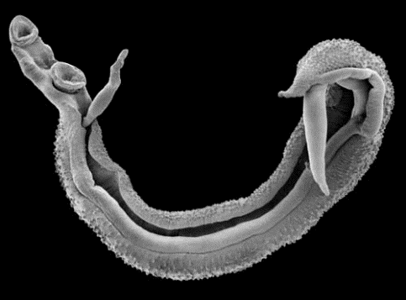
Show Flipchart B: The blood fluke
- Show the picture of the blood fluke to each student.
- Point out that this blood fluke is not pooped out in feces like the common worm people have seen in their stools.
- Explain that:
  - The blood fluke is a nasty-looking creature that lives inside the body.
  - The blood fluke makes people sick with schistosomiasis.
  - Even if you are infected, you can’t see it in your pee or stool. It is not pooped out like the common worm.
  - The blood fluke is very small, but it can cause a lot of damage to your body.
- Point out that, in the picture, the male fluke is on the outside, holding the female that lies inside. You can see the thin female sticking out of the male. You can see that this is not a common worm!

Ask: How does the blood fluke make you sick?
Answer: The blood fluke’s eggs make you sick. Some eggs pass out from the body of a person with schistosomiasis in the pee. Other eggs stay in the body and cause the symptoms.

Ask: How long can a blood fluke live inside the body if not treated with medicine?
Answer: A blood fluke can live in your body for as long as 25 years if not treated. A blood fluke can damage your body even when you do not feel sick.

Ask: Can you treat schistosomiasis?
Answer: There is a medicine called praziquantel that can kill the blood fluke. When a health worker gives you praziquantel, take all the tablets at the same time.

Lesson 2 Activity: Draw the blood fluke
- Ask each student to draw a picture of a blood fluke.
- Have one or two students show their drawings and talk about the blood fluke, including why it is different from a common worm.

Check for understanding
Ask: How does seeing this blood fluke make you feel?
Ask: How would you feel if it was living in your body?
Ask: Have you ever taken medicine for the blood fluke?
Ask: If you had these in your body, would you want to take the medicine?

Important note
People reported that seeing a picture of the blood fluke was the most powerful influence on changing behavior. Understanding the difference between the blood fluke and a regular worm makes people aware of the danger of schistosomiasis.

Lesson 3: What is the role of the schistosomiasis snail?

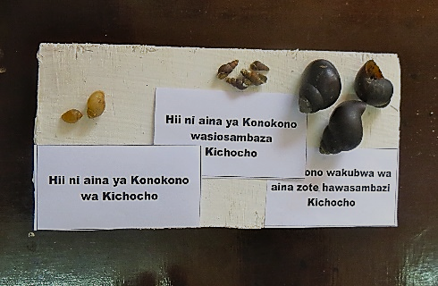
Objective:
- To describe and discuss the role of the schistosomiasis snail in schistosomiasis transmission
Activity:
- Identify the schistosomiasis snail
Materials:
- Flipchart C: The schistosomiasis snail
- Flipchart D: Where does the schistosomiasis snail live?
- Teacher’s Guide for Activities and Safe Play: Lesson 3 Activity
- Snail boards with three different types of snail shells glued to and labeled on the boards
  - One 8-inch x 4-inch board per person
  - Glue
  - Labels
  - Three types of snail shells, including
the schistosomiasis snail
Time:
- Presentation and discussion: 30 minutes
- Activity: 45 minutes

Ask: Why do you need to go into water to get schistosomiasis?
Answer: Only a special kind of snail can transmit urogenital schistosomiasis. This kind of snail lives in fresh water, like streams, ponds, lakes, rivers, and rice fields. It likes to live on or under leaves, reeds, wood, and garbage in the water. It does not live on the land or in the sea. Every time a person steps in water where infected schistosomiasis snails live, the person can get schistosomiasis.
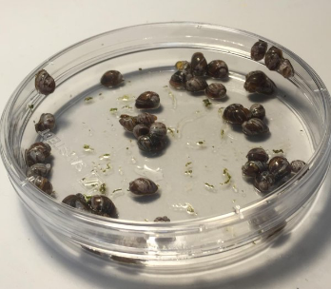
Ask: How big are the snails that transmit schistosomiasis?
Answer: They are very tiny, about the size of a child’s fingernail.

Ask: If someone pees on the ground and you step in it will you get schistosomiasis?
Answer: If a person steps in someone’s pee on land they will not get schistosomiasis. The schistosomiasis eggs in a person’s pee does not infect people directly. The blood fluke needs to live in a snail for a while before it can infect another person.

Show Flipchart C: The schistosomiasis snail
- Show the picture of the schistosomiasis snails. Point out that the snails are small -- about the size of a child’s fingernail.
- Emphasize that people should never pick up these snails.

Show Flipchart D: Where does the schistosomiasis snail live?
- Tell the students that the men in the pictures are looking for the schistosomiasis snails. They are looking under leaves and logs.
- Ask the students how they are protecting themselves from schistosomiasis?
  - They are wearing waders to cover their legs and gloves to protect their hands.
- Use the prompts on the back of the flipchart to encourage discussion.

Ask: Do you think it is easy to find schistosomiasis snails?
Answer: No, it takes a lot of work. They are very small, and you have to look underneath leaves, logs, and garbage to find them.

Lesson 3 Activity: Identify the schistosomiasis snail
- Follow the instructions for the activity, gluing the shells and labels on the board. Note that it is ok to touch the dried-out shells in the classroom, but not snails found outside near freshwater.
- Have one or two children show their snail boards and talk about the different types of snails.

Check for understanding
Ask: Can you name some places near where you live schistosomiasis snails might live? What are some places near our school?
Ask: Do you go in the water there? What activities do you do in the water?

Important note
Schistosomiasis snails live in fresh water, such as streams, ponds, lakes, rivers, and rice fields. Land and sea snails do not transmit schistosomiasis. Do not pick up snails that are in or near rivers, streams, ponds, rice fields, and lakes.

Lesson 4: What is the life cycle of the blood fluke?

Objectives:
To discuss the role of the blood fluke in schistosomiasis transmission
To discuss the life stages of the blood fluke from an egg until it matures in a person
Activity:
Understand the blood fluke life cycle
Materials:
Flipchart E: The blood fluke life cycle
Teacher’s Guide for Activities and Safe Play: Lesson 4 Activity
Cardboard template of a boy or girl
Manila or colored paper
Crayons, colored pencils or markers
Scissors
Time:
Presentation and discussion: 20 minutes
Activity: 45 minutes

Ask: What creature needs to be in the water for a person to get schistosomiasis?
Answer: A schistosomiasis snail

Ask: How does schistosomiasis get in the snail?
Answer: A person pees in the water

Ask: How does a person get schistosomiasis?
Answer: A person goes into water with infected snails

Show Flipchart E: The blood fluke life cycle
- Explain that the picture describes the life of a blood fluke.
- A blood fluke has many different life stages, including being an egg, living in a snail, living in water, and living in a human. All together, these stages are called the blood fluke life cycle.

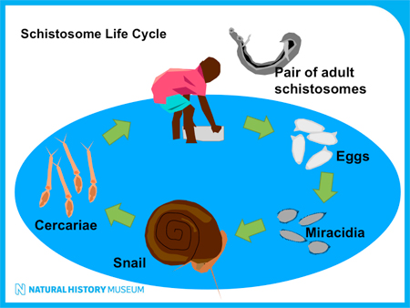

Ask: How does the blood fluke get into the body to make a person sick?
Answer: Adult blood flukes live in people. They release eggs into the pee. When someone with schistosomiasis pees in the water, they can pee out schistosomiasis eggs.

In the water, the eggs hatch into an immature form called miracidia, baby oval-shaped creatures. If a schistosomiasis snail is nearby, the miracidia quickly move into the snail. While in the snail, the miracidia become cercariae, little oval-shaped creatures with a forked tail, which can infect people. You cannot see miracidia or cercariae with your eyes.

The snails release the cercariae into the water. When a person goes into that water, the cercariae pierce the person’s skin and go into the person. Once inside the person, the cercariae change into schistosomiasis blood flukes. They travel to the bladder and start laying eggs. In the bladder, flukes and their eggs can cause great damage.

Lesson 4 Activity: The blood fluke life cycle
- After discussing the life cycle of the blood fluke, ask each student to make a poster depicting the life cycle, as shown below
- Have one or two students show their pictures and explain the life cycle

- Check for understanding
Ask: What creature needs to be in the water for a person to get schistosomiasis?
Ask: How does schistosomiasis get in the snail?
Ask: How does a person get schistosomiasis?
Ask: Who would like to present their life cycle poster to the class?

Important Note

Schistosomiasis can only be transmitted in water that has schistosomiasis snails. Land and sea snails do not cause this infection.

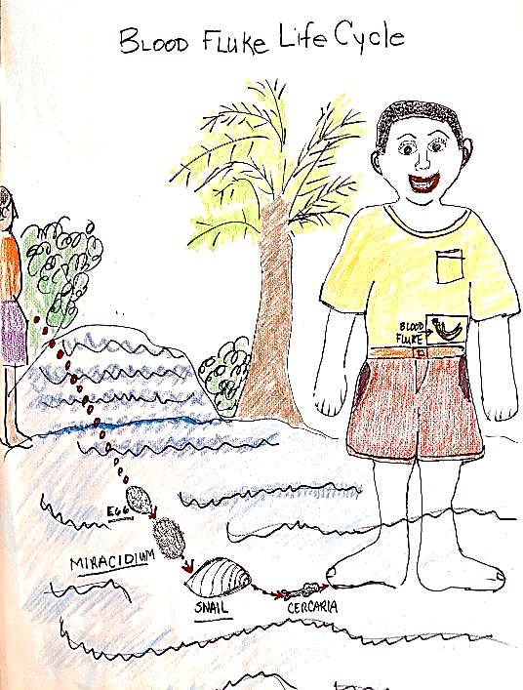
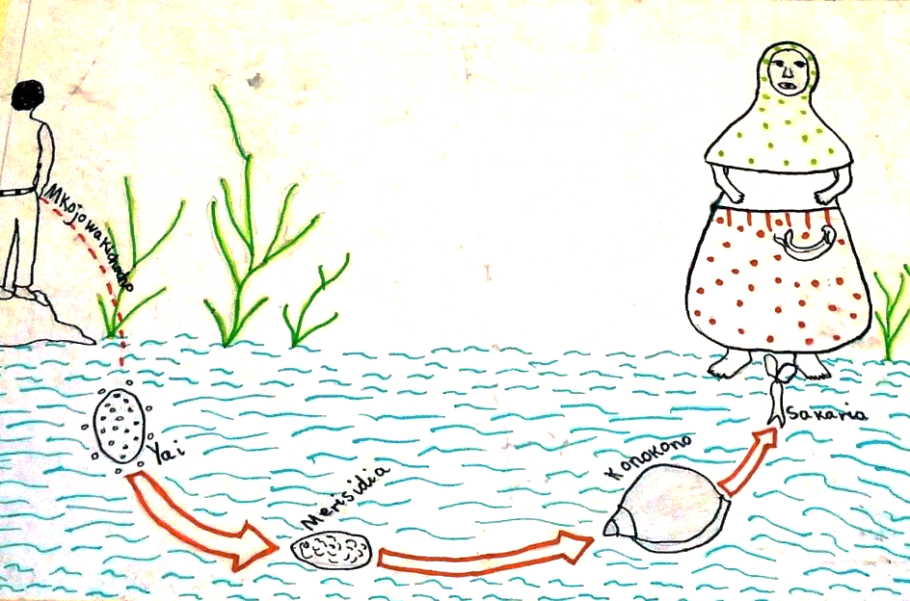

Lesson 5: What behaviors put children at risk for schistosomiasis?
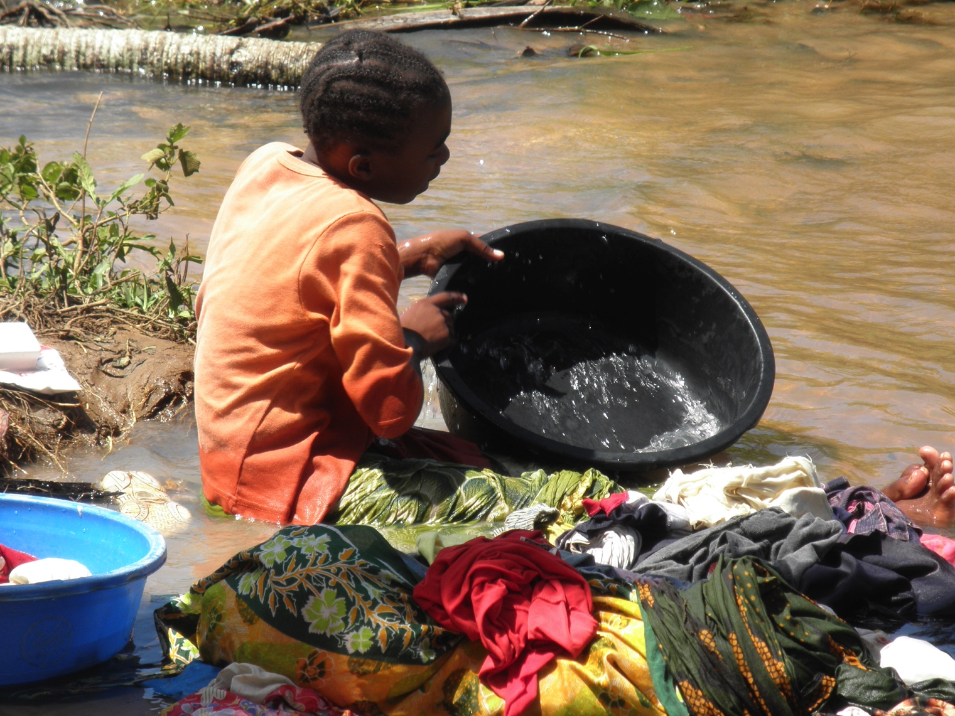
Objectives:
- To describe and discuss behaviors that put children at risk of schistosomiasis
- To identify local risky water sources where children may be exposed to schistosomiasis
Activity:
- Count the schistosomiasis snails
Materials:
- Flipchart F: Risk behaviors
- Teacher’s Guide for Activities and Safe Play. Lesson 5 Activity
(1 snail counting sheet for each student)
Time:
- Presentation and discussion: 15 minutes
- Activity: 30 minutes

Ask: How do children spread schistosomiasis?
Answer: When children with schistosomiasis pee into water with schistosomiasis snails, they spread the disease. The schistosomiasis eggs in their pee infect the schistosomiasis snails. Then, any people who go in the water can catch schistosomiasis.

Ask: How do children get infected with schistosomiasis?
Answer: They go into water that has infected snails.

Show Flipchart F: Risk behaviors

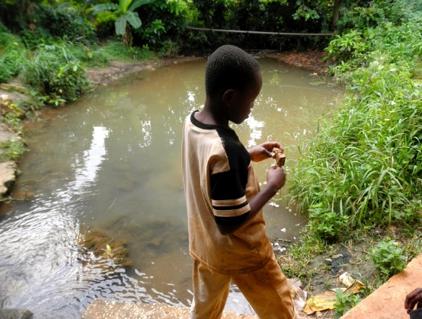
Ask: Who goes into the water for [ask for a show of hands after you say each activity]: Playing? Swimming? Washing clothes? Washing dishes? Bathing? Collecting water? Fishing? Taking care of animals? Working in rice fields?

Ask: How can you keep from getting schistosomiasis?
Answer: Stay out of water with schistosomiasis snails.

Lesson 5 Activity: Count the schistosomiasis snails
- Give each student Lesson 5 Activity Sheet: Count the schistosomiasis snails
- Remind students:
  - Schistosomiasis lives in very small snails found in streams, ponds, lakes, rivers, and rice fields with water
  - Children should not go in water where these snails might live.
  - Snails that live on land do not carry schistosomiasis.
  - Children should not pick up snails they find around streams, ponds, lakes, rivers, or rice fields.
- Check the students’ work. Ask how they got their answers. If they make mistakes, review the difference between where the schistosomiasis snails live and where other snails live.

Check for understanding
Ask: What can children do to keep from spreading schistosomiasis?
Answer: Do not pee in streams, ponds, lakes, rivers, or rice fields. Pee in latrines or toilets.

Ask: What are some activities children do that put them at risk for getting schistosomiasis?
Possible Answers:
- Playing or swimming in streams, ponds, lakes, rivers, and rice fields where schistosomiasis snails live
- Doing household chores such as collecting water, washing dishes and utensils, washing clothes, and tending animals in freshwater where schistosomiasis snails live
- Fishing in streams that have schistosomiasis snails
- Standing in rice fields that have schistosomiasis snails
- Walking barefoot through rice fields that have schistosomiasis snails

Ask: What can children do to reduce their risk for getting schistosomiasis?
Answer: Stay out of water with schistosomiasis snails

Important Note
Schistosomiasis snails live in fresh water, such as streams, ponds, lakes, rivers, and rice fields. Land snails and sea snails do not transmit schistosomiasis. Spending any time in water with infected snails can lead to getting schistosomiasis.

Lesson 6: What are the symptoms of urogenital schistosomiasis in children?

Objectives:
To recognize symptoms of schistosomiasis in children
To discuss the possible health effects of schistosomiasis in children
Activity:
None
Materials:
Flipchart G: Symptoms of schistosomiasis
Time:
Presentation and discussion: 20 minutes

Show Flipchart G: Symptoms of schistosomiasis
Ask: What are the symptoms of schistosomiasis?
Answer: Schistosomiasis can have many bad effects. Sometimes it is easy to tell you are sick from schistosomiasis. Sometimes people don’t realize how bad they feel until they get treated. Some people with schistosomiasis have symptoms like these:
- Feeling like you have to pee and then you can’t pee
- Pain in the lower belly
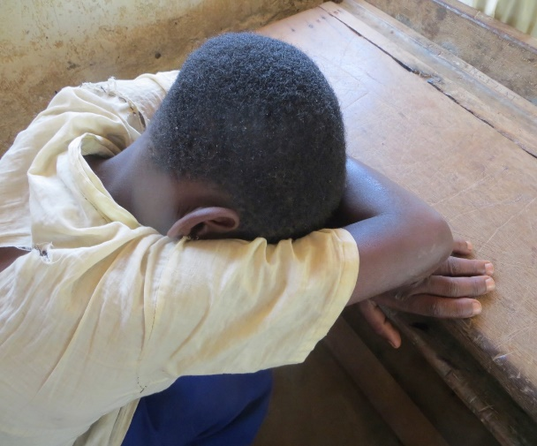
- Severe pain when peeing
- Itching of the private parts
- Peeing blood
- Sometimes having fever

Other symptoms may be harder to recognize as being due to schistosomiasis. These include:
- Feeling tired all the time
- Having less energy
- Having trouble paying attention in school
- Generally not feeling well

Ask: Does everyone with schistosomiasis show symptoms?
Answer: Some children and adults have schistosomiasis with no obvious symptoms. However, having no symptoms is not the same as being healthy. Even without obvious symptoms, schistosomiasis can still make children grow less, have less energy, and have a harder time learning and working. It is important to treat everyone who is infected, even if they do not have symptoms!

Ask: What happens when people have schistosomiasis for a long time and don’t get treated?
Answer: Besides affecting energy, growth, and learning, untreated schistosomiasis can lead to bladder cancer and difficulty for girls to have babies when they grow up.

Check for understanding
Ask: What are the symptoms of schistosomiasis?
Ask: Do boys and girls have the same symptoms? [Yes]
Ask: If you don’t feel sick, can you still have schistosomiasis?
Ask: Who remembers what is living inside you if you have schistosomiasis?
Ask: If you have that in you, do you want to be treated? Why?

Important note
Children and adults can have schistosomiasis without symptoms. That is why everyone needs to be treated during mass drug campaigns in areas with lots of disease.

Lesson 7: How do you test for and treat schistosomiasis?
Objectives:
To describe how schistosomiasis is diagnosed and treated
To understand the need for everyone to take tablets during mass drug administration campaigns
Activity:
Play the treatment game
Materials:
Flipchart H: Testing for schistosomiasis
Flipchart I: Treating schistosomiasis
Teacher’ Guide for Activities and Safe Play: Lesson 7 Activity
Sample praziquantel tablets (at least 3)
Three paper cups
Time:
Presentation and discussion: 15 minutes

Ask: How are children tested for schistosomiasis?
Answer: It is easy to find out if you have schistosomiasis. You pee in a cup. Then the health worker checks if there are blood or schistosomiasis eggs in the pee.

Show Flipchart H: Testing for schistosomiasis
- Show the picture of bloody vs clear urine (pee).
  - Point out that one cup of pee has blood in it and the other does not.
  - Show the picture of a health worker using a microscope to look for schistosomiasis eggs.
  - Remind the students that the eggs are very tiny and that you need a microscope to see them.

Ask: How do health workers treat children with schistosomiasis to get rid of the disease?
Answer: You can only treat schistosomiasis with a drug called praziquantel.
- Teas from the roots of a bush or bark of a tree do not rid the body of this disease.
- Drinking lots of water does not rid the body of this disease.
- The ugly blood fluke needs a powerful medicine, called praziquantel, to kill it.

Show Flipchart I: Treating schistosomiasis
Here is a mother seeking treatment for her young son with schistosomiasis.
- Explain that the best medicine for treating schistosomiasis is praziquantel.
- The number of praziquantel pills to take depends on your height or weight.
- It is important to take all the pills at once.

Lesson 7 Activity: Play the treatment game
- Explain that praziquantel is a white pill that kills the blood fluke.
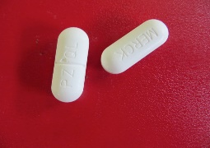
- Show the sample praziquantel tablets and discuss the medicine using the prompts in the Activity Packet.
- Play the game.

Ask: How safe is praziquantel?
Answer: The drug is safe whether you have schistosomiasis or not. It is best to take praziquantel when you have food in your stomach. If you take praziquantel on an empty stomach it will not hurt you, but your stomach may feel upset. If you have food in your stomach, the praziquantel will kill the blood fluke and it won’t upset your stomach.

Check for understanding
Ask: Tell us about the time you were given this medicine.
Ask: Discuss what you thought about it that time.
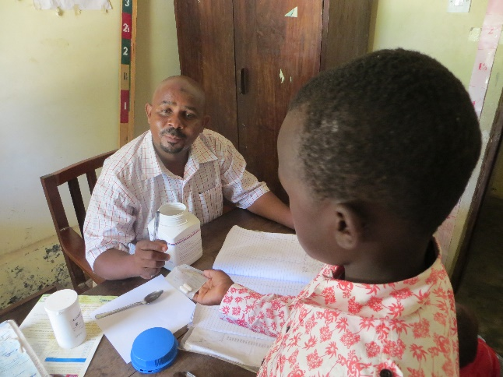
Ask: Would you take the medicine now?

Important note
The dangerous schistosomiasis blood fluke can be killed only with a strong medicine. All the praziquantel tablets the health worker gives you must be swallowed together to kill the blood fluke.

Lesson 8: How can safe games and activities help prevent schistosomiasis?

Objectives:
To discuss the importance of safe games and activities to prevent schistosomiasis
Activity:
One or two safe games, from the Teacher’s guide for activities and safe games
Materials:
Flipchart L: Preventing schistosomiasis
Flipchart K: Safe games and activities for boys
Flipchart L: Safe games and activities for girls
Teacher’ Guide for Activities and Safe Play (choose any game)
Materials needed for the games
Time:
Presentation and discussion: 15 minutes
Activities: 60-120 minutes
Ask: Where do you like to play? What do you like to play?
Answer: Play is important for children. But some kinds of play can put you at risk for getting schistosomiasis!

Ask: Where do you sometimes play that may put you at risk for getting schistosomiasis? What games do you like to play in these places? What other activities do you do in the water?
Answer: Playing in a river, stream, pond, rice field, or lake with snails infected with schistosomiasis is very dangerous for all children. Washing clothes and dishes and even washing your body can also be dangerous if you go in water with schistosomiasis snails. You can get sick with schistosomiasis even if you just put your foot in the water.

Ask: What are some safe games and activities that don’t involve going in the water?
Answer: There are many fun things to do outside of the water. These include drawing pictures, playing house, playing football, and having races.

Show Flipchart J: Preventing schistosomiasis
- Use the prompts on the back of the Flipchart to encourage discussion.

Show Flipcharts K and L: Safe games and activities for boys (Flipchart K) and for girls (Flipchart L)
- Use the prompts on the back of the flipcharts to encourage discussion.

Play one or two safe games
- After discussing examples of safe games, it is important for children to play a game. Refer to the instructions for games in the Teacher’ Guide for Activities and Safe Play

NOTE: The most important part of every game is the special questions! For example, when children fall down playing tug-of-war, the team that falls down is asked:
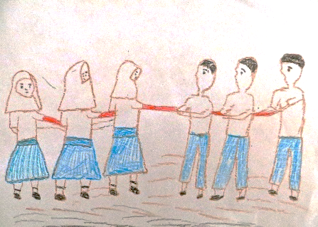
          - How did you get schistosomiasis?
          - How do you know you have schistosomiasis?
          - What are your symptoms?
          - How will you be treated?
          - How will you prevent getting schistosomiasis next time?

The winning team has prevented getting schistosomiasis. They are asked a different set of questions:
- How did you prevent getting schistosomiasis?
- What did you avoid doing to prevent getting schistosomiasis?
- What safe games did you play?
- What would you tell your friends who got schistosomiasis so they don’t get it again?

Create a Schistosomiasis Day Event for the classroom, the entire school or the community. Write up an agenda of interactive activities and games that could be played by students to teach others and schistosomiasis. (see worksheet)

At the end of the lesson check for understanding
Ask: Name some rivers, streams, or ponds where schistosomiasis snails might live.
Ask: What can happen if you play in these rivers, streams, or ponds where snails might live?
Ask: What kind of safe games and activities can you play instead of going into the water?

What activities and games could be included for a Schistosomiasis Day event to educate all students and other community members? Write out answers.

